JOB TITLE: Development Services Director | DEPARTMENT: Development Services
EMPLOYMENT STATUS: Full-time | FSLA: Exempt
PAY GRADE: 8 | SALARY RANGE: $66,410 - $92,974
REPORTS TO: CITY MANAGER

summary:
Under the general direction of the City Manager, the Community Development Services Director is the Department Head with responsibility for policy development, program planning, budget management, administration, and operational direction of the Community Development Services Department functions. Oversees and supervises Code Inspector & Development Services Admin./Permits Tech, and Health Inspector. Monitors the City’s National Flood Plain Program for compliance.
Essential Functions:
- Plans, organizes controls, integrates, and evaluates the work of the Community Developmental Services Department; with the staff, develops implements and monitors long-term plans, goals, and objectives.

- Plans, organizes, directs and evaluates the performance of the code enforcement division, building inspector, and contract inspectors; establishes performance requirements; regularly monitors performance and provides improvement feedback.

- Represents the City at the Board of Adjustments, Planning and Zoning, Substandard Structure Board and City Council meetings; informs and advises these groups, as well as the City Manager, on local and regional community developments, environmental and infrastructure planning issues; additionally, provides feedback and input on updating local ordinances, state codes and statues as needed.

- Conduct field investigations; inspect properties for violations of the Substandard Structure Ordinance; attempt to make contact at the residence or business in order to resolve violations; issue and post warning notices, notices of violation, correct notices, orders to comply, and related documentation for violations of the Substandard Structure Ordinance; schedule and perform all follow-up.

- Conduct plan reviews and on-site inspections to assure compliance with City Ordinances, building codes, and state or federal regulations.

- Successful completion of National Flood Plain Managers Program within one year of hire.

- Possess or have the ability to complete necessary required certifications for this position. Building Official, Combination Inspector or Plumbing Inspector.
- Being an integral role to adopt and implement the best practices in local government.
- Facilitating development projects in strengthening and expanding local economic base.
- Being a leader in innovation and customer-oriented team.
- Ability to proactively plan and to keep an eye on detailed matters.
BASIC FUNCTION:
- Assist walk-in customers/ contractors in the permit application process.
- Perform other duties as assigned.
ESSENTIAL WORK HABIT:
• Regular Attendance in a workplace environment.
- Maintain professional attitude and interaction during challenging moments.
Experience, Knowledge, and Skills Required
Knowledge of:
  - Principals and practices of construction terminology
  - Knowledge of civil engineering concepts, practices, and procedures related to civil, construction, and environmental planning.
  - Effective public relations practices.
  - Principals and procedures of record keeping.
  - Methods and techniques of business correspondence and technical preparation.
  - Modern office procedures, methods, and equipment including but not limited to computers, scanners, cameras, copiers and any other equipment that will be directly related to field activities.
Ability to:
- Respond to inquiries, complaints, and requests for service in a fair, tactful, and firm manner.
- Investigate complaints and mediate resolution in a timely and tactful manner.
- Prepare accurate and detailed documentation of investigations’ findings.
- Maintain logs, records, and files
- Research, compile, and collect data.
- Prepare clear and concise technical reports.
- Make oral presentations and testify in court.
- Work independently in the absence of supervision.
- Read and interpret legal documents and construct plans
- Understand and follow oral and written instructions.
- Type and enter data accurately at a speed necessary for successful job performance.
- Communicate clearly and concisely, both orally and in writing.
- Establish and maintain working relationships with those contacted in the course of work.
- Ability to attain the Incident Command System (ICS) certification 100, 200, 300, 400, 700, and 800
MINIMUM REQUIREMENTS FOR EMPLOYMENT:
Education and Experience:
- A minimum of five (5) years with extensive knowledge in municipal planning, zoning, plan review, building inspection, or related management roles, with supervisory experience. Bachelor’s degree in related fields such as planning, geography, or public administration is preferred by not required.
- Appropriate Texas driver's license or available alternative means of transportation.

- Plumbing inspector and electrical license
- American Institute of Certified Planners (AICP) designation is desired.
- Must be bondable

Physical Requirements:
DESCRIPTION OF PHYSICAL DEMANDS:
Frequency: C = Constantly (2/3 or more of the time); F = Frequently (1/3 to 2/3 of the time); O = Occasionally (up to 1/3 of the time); R = Rarely (less than 1 hour per week)
PHYSICAL DEMAND | FREQUENCY | DESCRIPTION OF DEMAND
Standing/ Walking | F | In an office setting - tile and carpet.
Sitting | F | In an office chair
Lifting/ Carrying | O | File folders, boxes, ledgers, etc. (max 25 lbs.)
Reaching | O | To reach materials in filing cabinets and on shelves.
Handling/ Fine Dexterity | F | To operate computer and write documents.
Bending | O | To obtain materials from lower drawers in filing cabinet.
Vision | C | To operate computer, read, inspect, and to operate a vehicle
Hearing/ Talking | C | To communicate with others.
Endurance / Stamina | F | Working 8 to 12 hours a day in a high demand environment meeting strict deadlines, which may create stress at times.

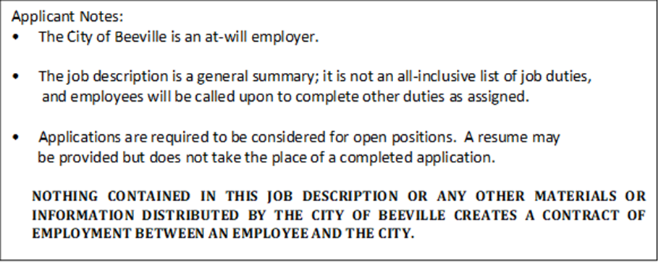

SIGNATURES AND DATES
Reasonable accommodation may be made to enable qualified individuals with disabilities to perform the essential functions of this job.
Check the appropriate box and fill in the appropriate accommodation, if required, then sign and date.
I have read and understand this job description and acknowledge that I am able to complete the
Essential function of my job without accommodations.
I have read and understand this job description and I would require the following reasonable accommodations to fulfill the essential functions of this job:
_________________________________________________________________________________________________________
_________________________________________________________________________________________________________
_________________________________________________________________________________________________________

________________________________________________________ ________________________
Employee Signature Date

________________________________________________________ ________________________
Supervisor Signature Date

________________________________________________________ ________________________
Human Resources Date

